**Project Design Phase-II**

**Data Flow Diagram & User Stories**

|  |  |
| --- | --- |
| Date | 1 November 2022 |
| Team ID | PNT2022TMID18041 |
| Project Name | Hazardous Area Monitoring for Industrial Plant powered by IoT |
| Maximum Marks | 4 Marks |

**Data Flow Diagrams:**

A Data Flow Diagram (DFD) is a traditional visual representation of the information flows within a system. A neat and clear DFD can depict the right amount of the system requirement graphically. It shows how data enters and leaves the system, what changes the information, and where data is stored.

# DFD Level 0

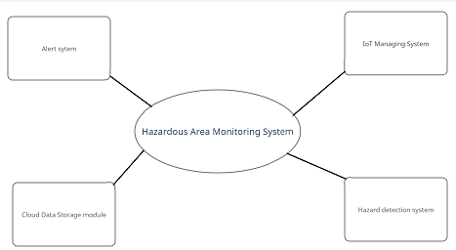

# DFD Level 1

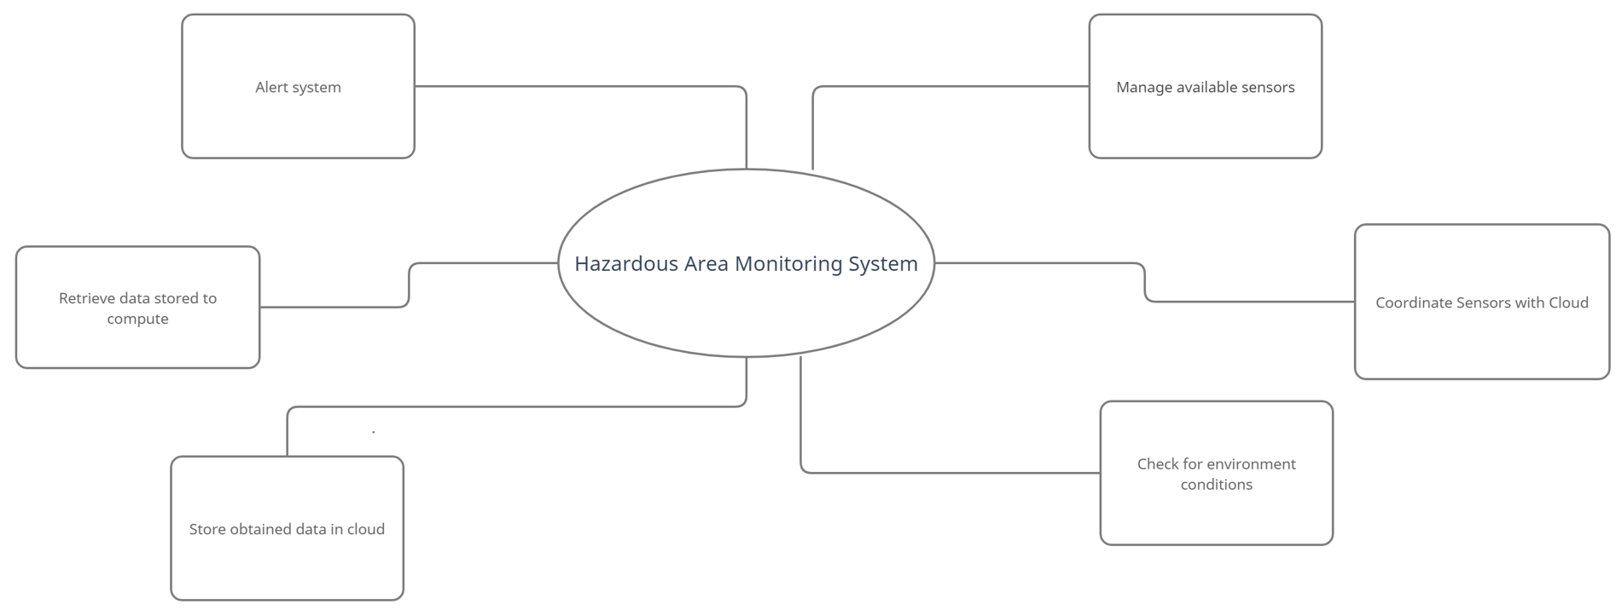

# DFD Level 2

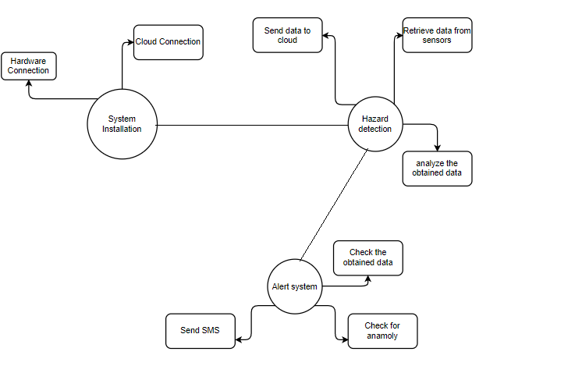

# User Stories

Use the below template to list all the user stories for the product.

|  |  |  |  |  |  |  |
| --- | --- | --- | --- | --- | --- | --- |
| **User Type** | **Functional Requirement (Epic)** | **User Story Number** | **User Story / Task** | **Acceptance criteria** | **Priority** | **Release** |
| Technician | Installation | USN-1 | The technician must install the smart beacons  at points to ensure the entire area of the plant is covered. | A beacon can be found in every area of the plant. | High | Sprint-1 |
|  | Data Gathering | USN-2 | The beacons obtain the temperature of their respective area using sensors. | The temperature of areas within the plant is obtained. | High | Sprint-1 |
|  | Data Sync | USN-3 | The beacons send their data to the cloud in the real time which is in turn sent to nearby wearable devices and the administrators dashboard. | Data is sent to the cloud successfully and synced with other devices. | High | Sprint-1 |
| Worker | Wearable device display | USN-4 | The wearable devices should display the data sent by beacons within the area. | The user can see the  temperature of the area on their device. | High | Sprint-1 |
|  | Wearable device adjustments | USN-5 | The user can adjust the size of the wearable device to better suit them. | The user can make adjustments to the device to make working with it more comfortable. | Low | Sprint-2 |
|  | Wearable display customization | USN-6 | The user can adjust the device display to suit their needs on the device itself. | The user can modify the display of the device to increase readability. | Medium | Sprint-2 |
|  | SMS Notifications | USN-7 | The user is sent a notification to their phone from the wearable device through an API when the area they are in reaches dangerous  temperatures. | The user is informed of potential danger via SMS as soon as it is detected by  the beacons. | High | Sprint-1 |
| Administrator | Admin Dashboard | USN-8 | The beacons send the data through the cloud to a dashboard which is run by the administrator. | The data of all the beacons can be viewed by the administrator of the plant. | High | Sprint-1 |
|  | Dashboard Customization | USN-9 | The dashboard can be customized by the admin  to suit their personal requirements and priorities. | The admin can customize the UI for their dashboard. | Medium | Sprint-2 |